**A Gesture-based Tool for Sterile Browsing of Radiology Images**

**Team ID- PNT2022TMID17537**

Run The Application :

At last, we will run our flask application

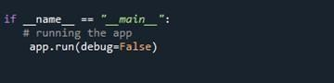

Run The app in local browser

* Open anaconda prompt from the start menu
* Navigate to the folder where your python script is.
* Now type “python app.py” command

Navigate to the localhost where you can view your web page



Then it will run on localhost:5000

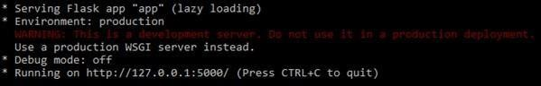

Navigate to the localhost (http://127.0.0.1:5000/)where you can viewyourweb page.